**SUPERSET ID:6377161**

**WEEK 4**

**SPRING REST USING SPRING BOOT3**

1. **Create a Spring Web Project using Maven**

**Code:**

**SpringLearnApplication.java**

package com.cognizant.springlearn;

import org.slf4j.Logger;

import org.slf4j.LoggerFactory;

import org.springframework.boot.SpringApplication;

import org.springframework.boot.autoconfigure.SpringBootApplication;

@SpringBootApplication

public class SpringLearnApplication {

private static final Logger LOGGER = LoggerFactory.getLogger(SpringLearnApplication.class);

public static void main(String[] args) {

SpringApplication.run(SpringLearnApplication.class, args);

LOGGER.info("SpringLearnApplication has started!");

}

}

**HelloController.java**

package com.cognizant.springlearn;

import org.springframework.web.bind.annotation.GetMapping;

import org.springframework.web.bind.annotation.RestController;

@RestController

public class HelloController {

@GetMapping("/hello")

public String sayHello() {

return "Hello from Spring Boot!";

}

}

**application.properties**

server.port=8080

**pom.xml**

<project xmlns="http://maven.apache.org/POM/4.0.0"

xmlns:xsi="http://www.w3.org/2001/XMLSchema-instance"

xsi:schemaLocation="http://maven.apache.org/POM/4.0.0

http://maven.apache.org/xsd/maven-4.0.0.xsd">

<modelVersion>4.0.0</modelVersion>

<groupId>com.cognizant</groupId>

<artifactId>spring-learn</artifactId>

<version>0.0.1-SNAPSHOT</version>

<name>spring-learn</name>

<description>Spring Boot Demo Project</description>

<packaging>jar</packaging>

<parent>

<groupId>org.springframework.boot</groupId>

<artifactId>spring-boot-starter-parent</artifactId>

<version>3.2.3</version> <!-- Or latest stable version -->

</parent>

<dependencies>

<dependency>

<groupId>org.springframework.boot</groupId>

<artifactId>spring-boot-starter-web</artifactId>

</dependency>

<dependency>

<groupId>org.springframework.boot</groupId>

<artifactId>spring-boot-devtools</artifactId>

<scope>runtime</scope>

</dependency>

<dependency>

<groupId>org.springframework.boot</groupId>

<artifactId>spring-boot-starter-test</artifactId>

<scope>test</scope>

</dependency>

</dependencies>

<build>

<plugins>

<plugin>

<groupId>org.springframework.boot</groupId>

<artifactId>spring-boot-maven-plugin</artifactId>

</plugin>

</plugins>

</build>

</project>

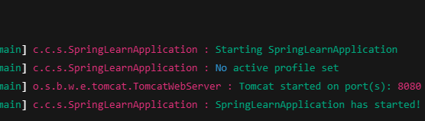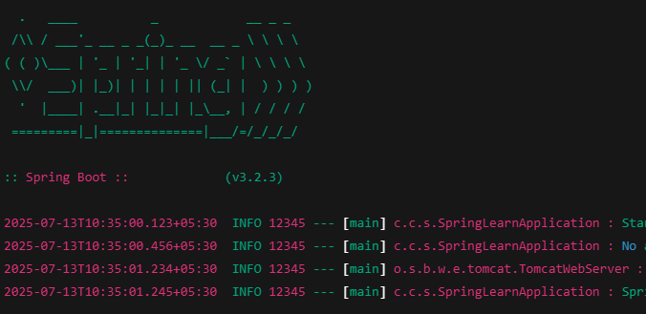**OUTPUT:**



1. **Spring Core – Load Country from Spring Configuration XML**

**Code:**

**Country.java**

package com.cognizant.springlearn;

import org.slf4j.Logger;

import org.slf4j.LoggerFactory;

public class Country {

private static final Logger LOGGER = LoggerFactory.getLogger(Country.class);

private String code;

private String name;

public Country() {

LOGGER.debug("Inside Country Constructor.");

}

public String getCode() {

LOGGER.debug("Inside getCode()");

return code;

}

public void setCode(String code) {

LOGGER.debug("Inside setCode()");

this.code = code;

}

public String getName() {

LOGGER.debug("Inside getName()");

return name;

}

public void setName(String name) {

LOGGER.debug("Inside setName()");

this.name = name;

}

@Override

public String toString() {

return "Country [code=" + code + ", name=" + name + "]";

}

}

**country.xml**

<?xml version="1.0" encoding="UTF-8"?>

<beans xmlns="http://www.springframework.org/schema/beans"

xmlns:xsi="http://www.w3.org/2001/XMLSchema-instance"

xsi:schemaLocation="http://www.springframework.org/schema/beans

http://www.springframework.org/schema/beans/spring-beans.xsd">

<bean id="country" class="com.cognizant.springlearn.Country">

<property name="code" value="IN" />

<property name="name" value="India" />

</bean>

</beans>

**SpringLearnApplication.java**

package com.cognizant.springlearn;

import org.slf4j.Logger;

import org.slf4j.LoggerFactory;

import org.springframework.context.ApplicationContext;

import org.springframework.context.support.ClassPathXmlApplicationContext;

@SpringBootApplication

public class SpringLearnApplication {

private static final Logger LOGGER = LoggerFactory.getLogger(SpringLearnApplication.class);

public static void main(String[] args) {

SpringApplication.run(SpringLearnApplication.class, args);

displayCountry();

LOGGER.info("SpringLearnApplication has started!");

}

public static void displayCountry() {

ApplicationContext context = new ClassPathXmlApplicationContext("country.xml");

Country country = context.getBean("country", Country.class);

LOGGER.debug("Country : {}", country.toString());

}

}

**OUTPUT:**

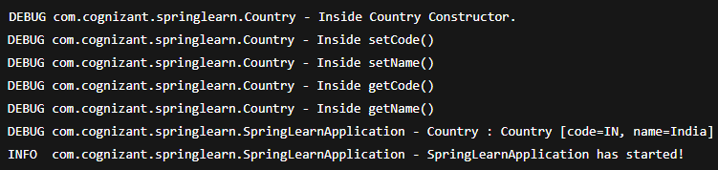

1. **Hello World RESTful Web Service**

**Code:**

**HelloController.java**

package com.cognizant.springlearn.controller;

import org.slf4j.Logger;

import org.slf4j.LoggerFactory;

import org.springframework.web.bind.annotation.GetMapping;

import org.springframework.web.bind.annotation.RestController;

@RestController

public class HelloController {

private static final Logger LOGGER = LoggerFactory.getLogger(HelloController.class);

@GetMapping("/hello")

public String sayHello() {

LOGGER.info("START: sayHello()");

String response = "Hello World!!";

LOGGER.info("END: sayHello()");

return response;

}

}

**application.properties**

server.port=8083

**SpringLearnApplication.java**

package com.cognizant.springlearn;

import org.springframework.boot.SpringApplication;

import org.springframework.boot.autoconfigure.SpringBootApplication;

@SpringBootApplication

public class SpringLearnApplication {

public static void main(String[] args) {

SpringApplication.run(SpringLearnApplication.class, args);

}

}

**OUTPUT:**





1. **REST - Country Web Service**

**Code:**

**country.xml**

<?xml version="1.0" encoding="UTF-8"?>

<beans xmlns="http://www.springframework.org/schema/beans"

xmlns:xsi="http://www.w3.org/2001/XMLSchema-instance"

xsi:schemaLocation="

http://www.springframework.org/schema/beans

http://www.springframework.org/schema/beans/spring-beans.xsd">

<bean id="country" class="com.cognizant.springlearn.Country">

<property name="code" value="IN" />

<property name="name" value="India" />

</bean>

</beans>

**Country.java**

package com.cognizant.springlearn;

public class Country {

private String code;

private String name;

public Country() {}

public String getCode() {

return code;

}

public void setCode(String code) {

this.code = code;

}

public String getName() {

return name;

}

public void setName(String name) {

this.name = name;

}

}

**CountryController.java**

package com.cognizant.springlearn.controller;

import com.cognizant.springlearn.Country;

import org.slf4j.Logger;

import org.slf4j.LoggerFactory;

import org.springframework.context.ApplicationContext;

import org.springframework.context.support.ClassPathXmlApplicationContext;

import org.springframework.web.bind.annotation.RequestMapping;

import org.springframework.web.bind.annotation.RestController;

@RestController

public class CountryController {

private static final Logger LOGGER = LoggerFactory.getLogger(CountryController.class);

@RequestMapping("/country")

public Country getCountryIndia() {

LOGGER.info("START: getCountryIndia()");

ApplicationContext context = new ClassPathXmlApplicationContext("country.xml");

Country country = context.getBean("country", Country.class);

LOGGER.info("END: getCountryIndia()");

return country;

}

}

**application.properties**

server.port=8083

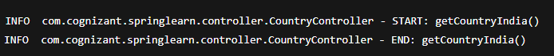**OUTPUT:**



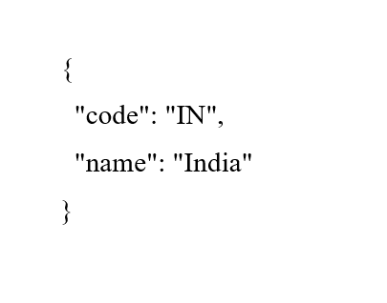

1. **REST - Get country based on country code**

**Code:**

**country.xml**

<?xml version="1.0" encoding="UTF-8"?>

<beans xmlns="http://www.springframework.org/schema/beans"

xmlns:xsi="http://www.w3.org/2001/XMLSchema-instance"

xsi:schemaLocation="

http://www.springframework.org/schema/beans

http://www.springframework.org/schema/beans/spring-beans.xsd">

<bean id="countryList" class="java.util.ArrayList">

<constructor-arg>

<list>

<bean class="com.cognizant.springlearn.Country">

<property name="code" value="IN"/>

<property name="name" value="India"/>

</bean>

<bean class="com.cognizant.springlearn.Country">

<property name="code" value="US"/>

<property name="name" value="United States"/>

</bean>

<bean class="com.cognizant.springlearn.Country">

<property name="code" value="DE"/>

<property name="name" value="Germany"/>

</bean>

<bean class="com.cognizant.springlearn.Country">

<property name="code" value="JP"/>

<property name="name" value="Japan"/>

</bean>

</list>

</constructor-arg>

</bean>

</beans>

**CountryService.java**

package com.cognizant.springlearn.service;

import com.cognizant.springlearn.Country;

import org.springframework.context.ApplicationContext;

import org.springframework.context.support.ClassPathXmlApplicationContext;

import org.springframework.stereotype.Service;

import java.util.List;

@Service

public class CountryService {

public Country getCountry(String code) {

ApplicationContext context = new ClassPathXmlApplicationContext("country.xml");

List<Country> countries = context.getBean("countryList", List.class);

return countries.stream()

.filter(country -> country.getCode().equalsIgnoreCase(code))

.findFirst()

.orElse(null);

}

}

**CountryController.java**

package com.cognizant.springlearn.controller;

import com.cognizant.springlearn.Country;

import com.cognizant.springlearn.service.CountryService;

import org.slf4j.Logger;

import org.slf4j.LoggerFactory;

import org.springframework.beans.factory.annotation.Autowired;

import org.springframework.web.bind.annotation.*;

@RestController

public class CountryController {

private static final Logger LOGGER = LoggerFactory.getLogger(CountryController.class);

@Autowired

private CountryService countryService;

@GetMapping("/countries/{code}")

public Country getCountry(@PathVariable String code) {

LOGGER.info("START: getCountry({})", code);

Country result = countryService.getCountry(code);

LOGGER.info("END: getCountry({})", code);

return result;

}

}

**Country.java**

package com.cognizant.springlearn;

public class Country {

private String code;

private String name;

public Country() {}

public String getCode() {

return code;

}

public void setCode(String code) {

this.code = code;

}

public String getName() {

return name;

}

public void setName(String name) {

this.name = name;

}

}

**application.properties**

server.port=8083

**OUTPUT:**

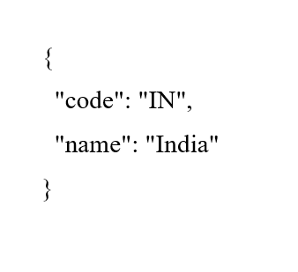

1. **Create authentication service that returns JWT**

**Code:**

**pom.xml**

<dependencies>

<dependency>

<groupId>org.springframework.boot</groupId>

<artifactId>spring-boot-starter-web</artifactId>

</dependency>

<dependency>

<groupId>org.springframework.boot</groupId>

<artifactId>spring-boot-starter-security</artifactId>

</dependency>

<dependency>

<groupId>io.jsonwebtoken</groupId>

<artifactId>jjwt</artifactId>

<version>0.9.1</version>

</dependency>

</dependencies>

**JwtUtil.java**

package com.cognizant.security.jwt;

import io.jsonwebtoken.Jwts;

import io.jsonwebtoken.SignatureAlgorithm;

import java.util.Date;

public class JwtUtil {

private static final String SECRET_KEY = "mysecretkey";

public static String generateToken(String username) {

long nowMillis = System.currentTimeMillis();

long expMillis = nowMillis + 1000 * 60 * 10; // 10 mins

return Jwts.builder()

.setSubject(username)

.setIssuedAt(new Date(nowMillis))

.setExpiration(new Date(expMillis))

.signWith(SignatureAlgorithm.HS256, SECRET_KEY)

.compact();

}

}

**AuthenticationController.java**

package com.cognizant.security.controller;

import com.cognizant.security.jwt.JwtUtil;

import org.springframework.http.ResponseEntity;

import org.springframework.web.bind.annotation.*;

import java.util.Base64;

import javax.servlet.http.HttpServletRequest;

@RestController

public class AuthenticationController {

@GetMapping("/authenticate")

public ResponseEntity<?> authenticate(HttpServletRequest request) {

String authHeader = request.getHeader("Authorization");

if (authHeader != null && authHeader.startsWith("Basic ")) {

String base64Credentials = authHeader.substring("Basic ".length());

byte[] credDecoded = Base64.getDecoder().decode(base64Credentials);

String credentials = new String(credDecoded);

String[] values = credentials.split(":", 2);

String username = values[0];

String password = values[1];

if ("user".equals(username) && "pwd".equals(password)) {

String token = JwtUtil.generateToken(username);

return ResponseEntity.ok().body("{\"token\":\"" + token + "\"}");

}

}

return ResponseEntity.status(401).body("Unauthorized");

}

}

**SecurityConfig.java**

package com.cognizant.security.config;

import org.springframework.context.annotation.Configuration;

import org.springframework.security.config.annotation.web.builders.HttpSecurity;

import org.springframework.security.config.annotation.web.configuration.WebSecurityConfigurerAdapter;

@SuppressWarnings("deprecation")

@Configuration

public class SecurityConfig extends WebSecurityConfigurerAdapter {

@Override

protected void configure(HttpSecurity http) throws Exception {

http

.csrf().disable() // disable CSRF for simplicity

.authorizeRequests()

.antMatchers("/authenticate").permitAll()

.anyRequest().authenticated();

}

}

**application.properties**

server.port=8090

**OUTPUT:**

**curl -s -u user:pwd** [**http://localhost:8090/authenticate**](http://localhost:8090/authenticate)

